CS5590-0003: web/cloud/mobile programming
Part II Lab 1: Social Media Visualization and Android App.
Fall 2018
UMKC
Kim-Ndor Djimadoumngar

Assignment 1. Writing a program to visualize friends from Github
I created three files in WebStorm, MyFriends.html, MyFriends.css, and MyFriends.js, respectfully. The purpose is to see the Github one’s friends.
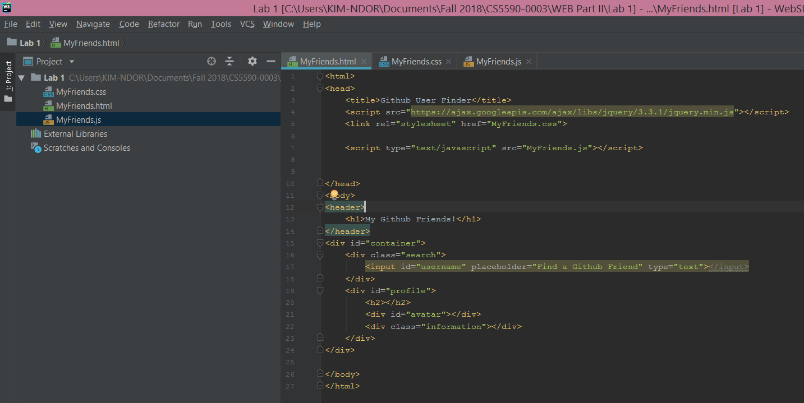
Results
The screenshot of the result after running the codes is as below:
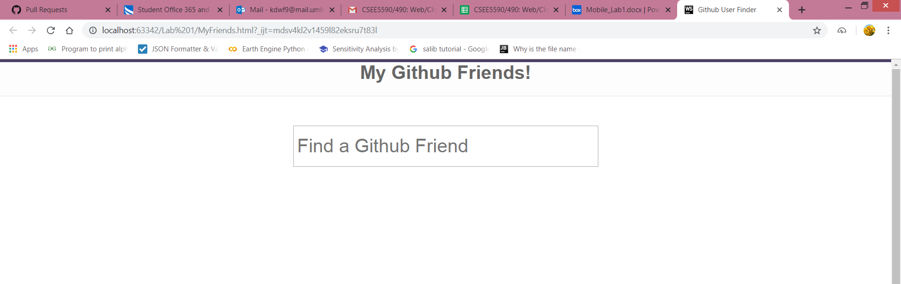

Assignment 2. Creata an app for university login/registration.
I used Android Studio to create an app named MobileAppKim. The app has a Login page, a registration page, and a Logout page for university usage purpose, which is the ultimate goal of this assignment.. The user’s basic information is displayed in the fron-end page.

Login Page
Text
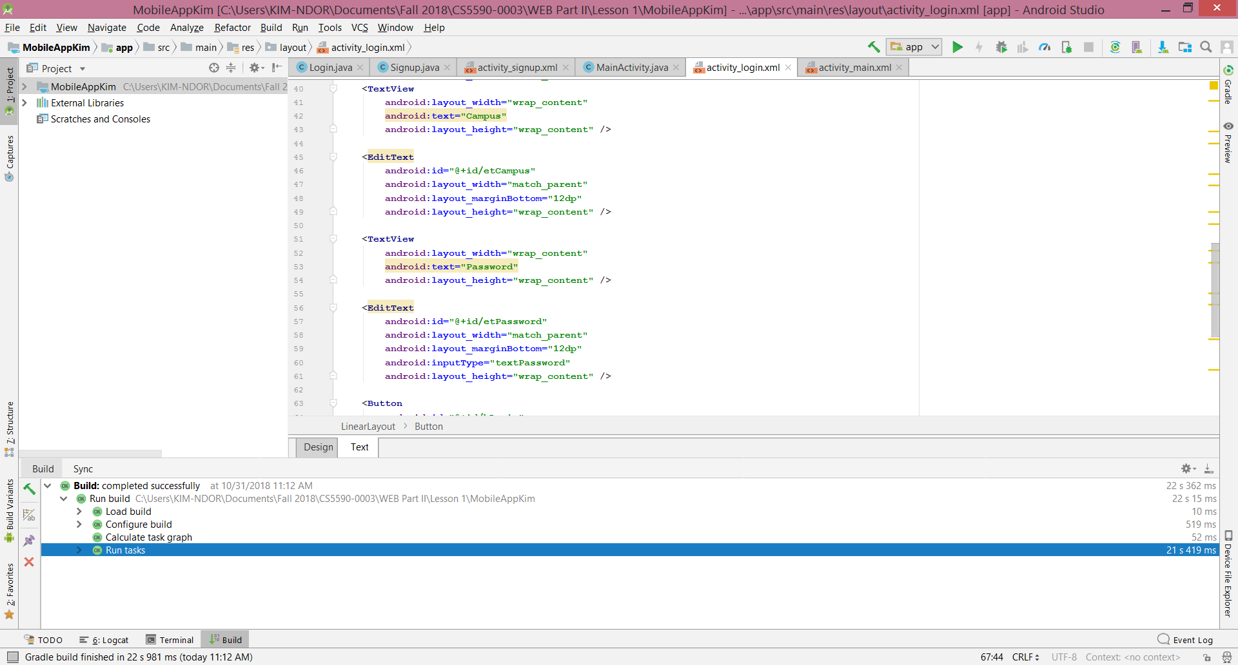
Design
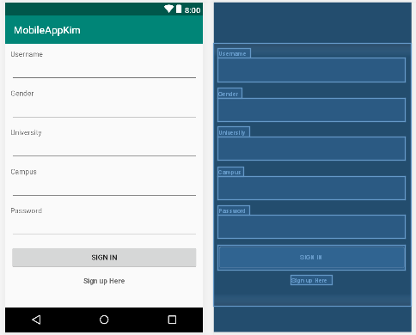
Sign Up Page
Text
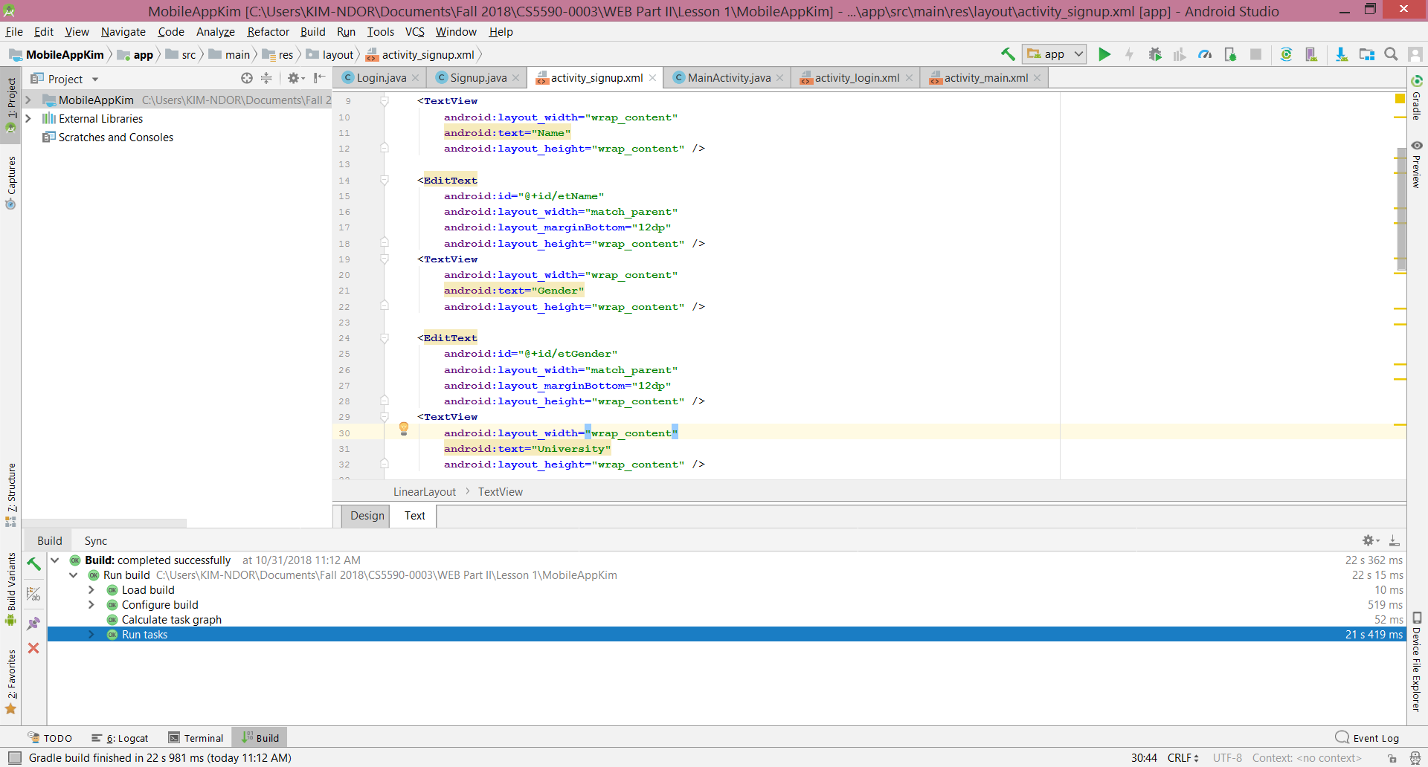
Design
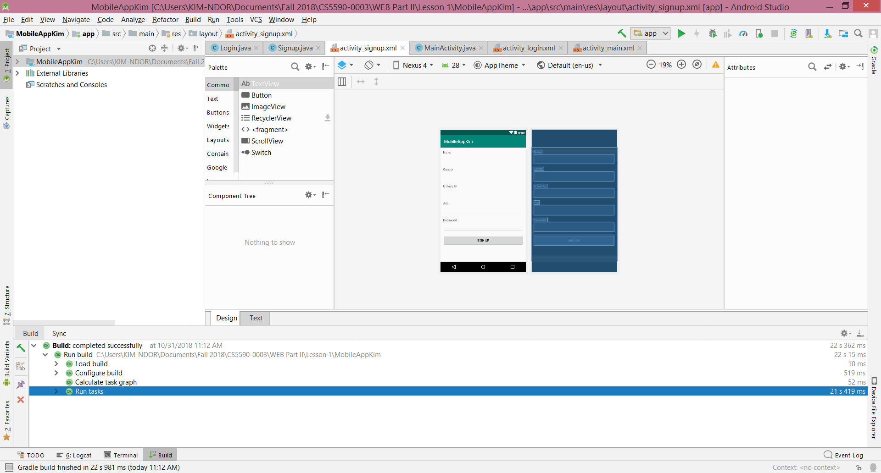
Main Activity Page
Text
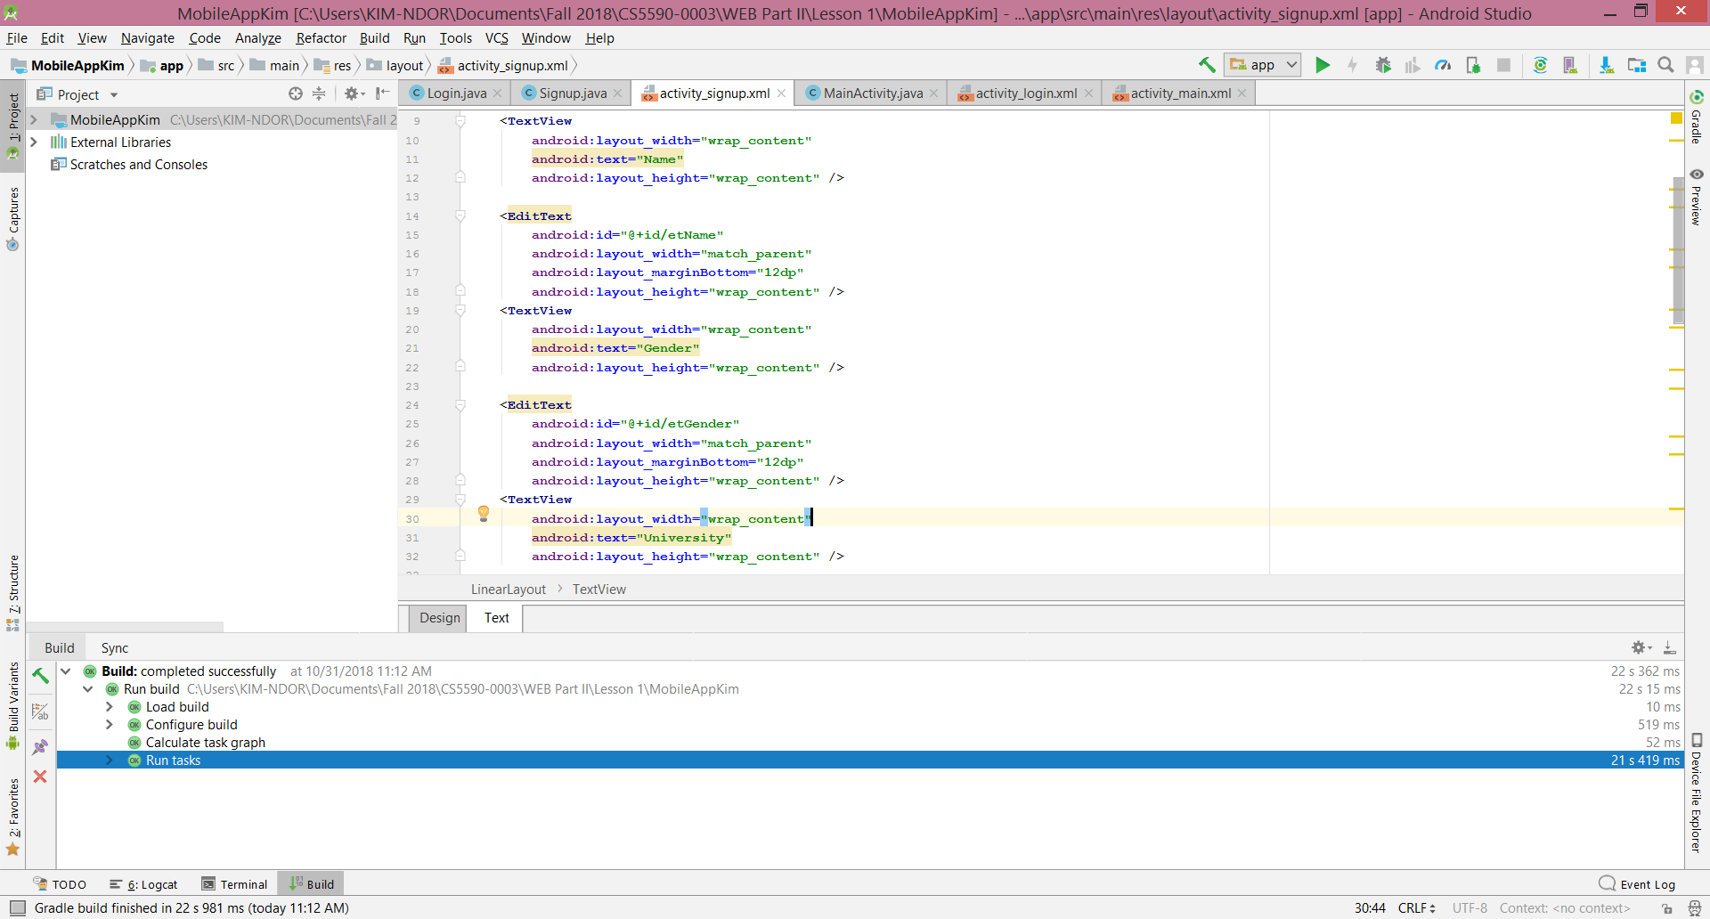
Design
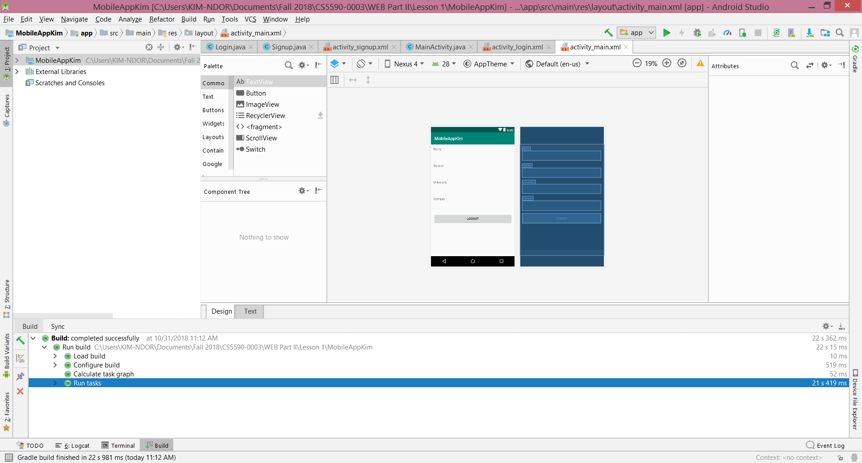
Reference
Chryssa Aliferi. Android Programming Cookbook. Kick-Start your Android projects.
Thomas, S. A., (2015). Data visualization with JavaScript. ISBN 978-1-59327-605-8

